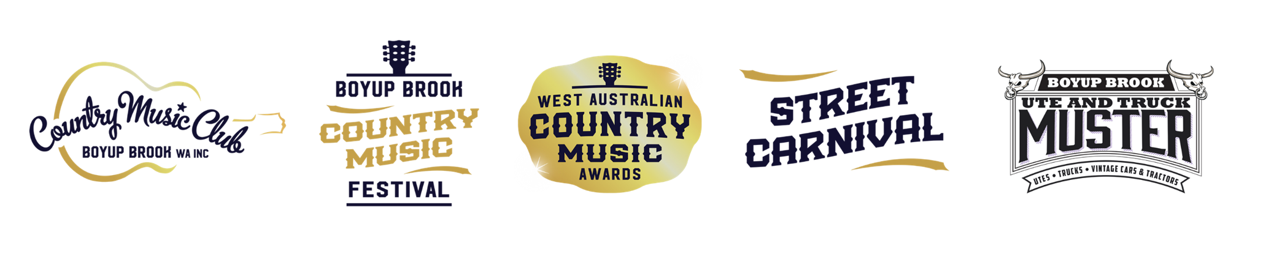

2021-22 MEMBERSHIP
1 April 2021 – 31 March 2022

- 10% Discount on club merchandise
- 10% Discount on festival tickets

Personal Details
Name: | Contact Number:
Address: | State: | Postcode:
Email:
Are you | ☐ Male ☐ Female ☐ Prefer not to say
Do you identify as | ☐ Indigenous ☐ Torres Strait Islander ☐ Prefer not to say

Which age group are you?
☐ 18-24 | ☐ 25-34 | ☐ 35-44 | ☐ 45-54 | ☐ 55-64 | ☐ 65+

Which region are you from?
☐ Gascoyne | ☐ Goldfields/Esperance | ☐ Great Southern | ☐ Kimberley | ☐ Mid West
☐ Peel | ☐ Perth/Metro | ☐ Pilbara | ☐ South West | ☐ Wheatbelt

I would love to volunteer at the Boyup Brook Country Music Festival | ☐ Yes ☐ No

Membership Type
Individual | $25.00 ☐
Artist | $20.00 ☐
Student (proof of student I.D required | $10.00 ☐

Payment Options
Credit / Debit Card Details | Card Number
 | CCV |  |  | Expiry Date |  |  |  | / |  |  | Amount |  |  | $
 | Cardholders Signature
Direct Deposit | Country Music Club of Boyup Brook WA Inc.  Bendigo Bank – BSB: 633-000 Account #: 160958930
 | Reference: Surname + First initial + Membership

All personal information remains confidential and will not be disclosed to any outside bodies without the express consent of the member.

Signed: | Date:

Membership form to be mailed to: -

Country Music Club of Boyup Brook WA Inc
72 Abel St
BOYUP BROOK WA 6244

Or emailed to – hello@wacountrymusic.com.au
Thank you for your support!

